Game Design Document

Overview

You are a Space Explorer employed by the Galactic Federation. Your job is to chart out unexplored areas of the Galaxy. You have just been sent out on a new mission to an isolated and remote area of space.
While exploring you become stuck in an asteroid belt. Your job is to clear out the asteroids and complete the task of charting this area of the Galaxy for the Galactic Federation before time runs out. Controls: arrow keys to move.

Game Design

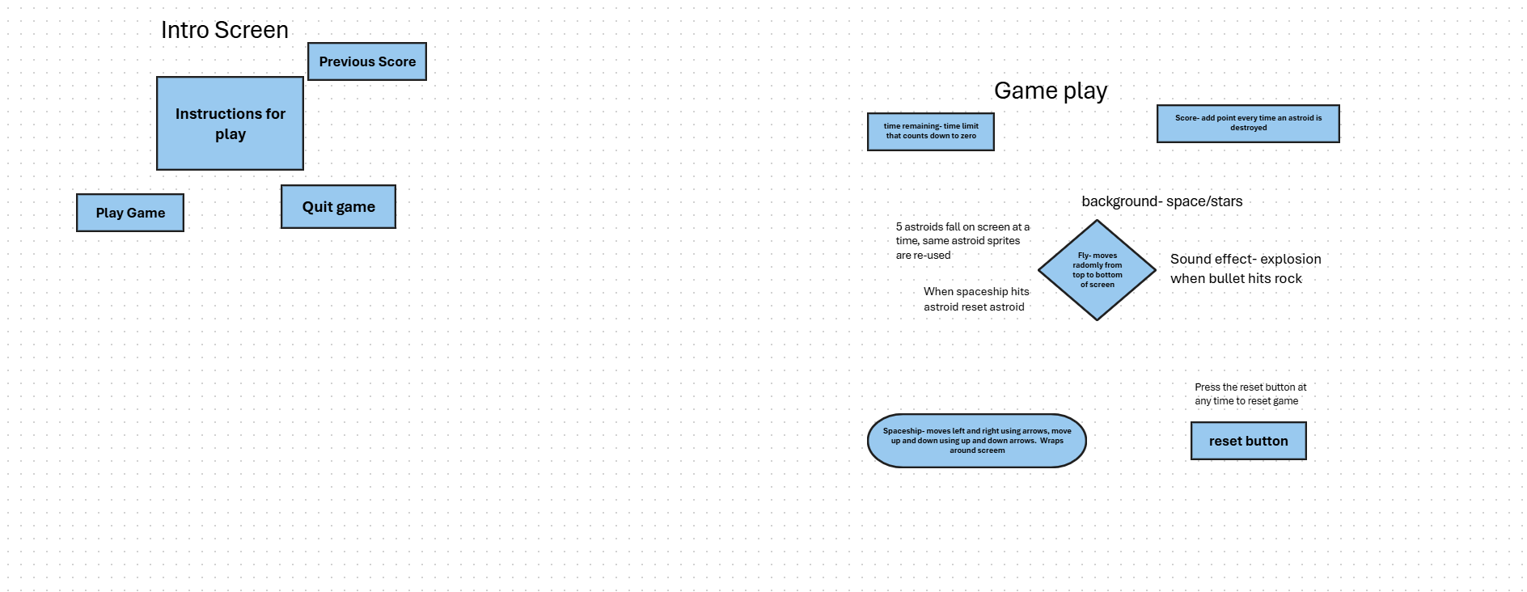

Game states
Intro ->gameplay->pause->gameplay or Quit

- Intro
  - Show Title
  - Show playGame
  - Show Quit
  - Show previousScore
- Game Play
  - Title hidden
  - btnReset hidden
  - btn Quit hidden
  - Show all sprites
  - Score and timer reset
- Pause
  - Title hidden
  - Sprites hidden
  - Show btnQuit
  - Show btnReset
- Quit
  - Game ends

Sprites:
- Spaceship
  - User-controlled
  - Slides left to right using left and right arrow
  - Slides up and down using up and down arrows
  - Wraps around screen
  - When hits asteroid, reset asteroid, and add point
- Asteroid
  - Computer controlled
  - Random randomly from top of screen to bottom at random speeds
  - Wraps around screen
  - When bullet hits, reset self
  - Reset- change placement randomly
  - Multiple asteroids on screen. Start with three

UI components
- Background
  - Some sort of star or galaxy screen
  - Should be “space”
  - Should make it easy to see spaceship and asteroids
- Title
  - Basic instructions screen multilabel
  - When playGame button is clicked- play game
  - When Quit button is clicked- quit game
- LblTimer
  - Will start at designated time
  - Label will always show time left
  - When time gets to zero, game ends
  - Game over- show reset and quit buttons
- LblScore
  - Label showing current score
  - Add points for each spaceship-asteroid collision
- BtnReset
  - Shows in pause state
  - When clicked goes back to gameplay state
  - Hide buttons
  - Show all Sprites
  - Reset score and timer
- BtnQuit
  - Appears on pause screen and title screen
  - When clicked, exits entire game
- PlayGame
  - Appears on title screen
  - When clicked, starts game

Sound Effects

- Gun fire
  - Played when spaceship fires bullets
- Explosion impact
  - Played when bullet collides with Asteroid
Milestones
- Gather placeholder resources
- Get basic form of game class running
- Add Spaceship Class
- Add Asteroid class
- Add bullet class
- Check standard collision
- Create list of asteroids, check collision behavior with multiple asteroids
- Add scorekeeping in lblscore and test
- Add timekeeping in lblTime and test
- Add quit button
- Add reset button
- Add intro
Game Tuning
- Speed of spaceship
- Speed of Asteroids
- Randomness of asteroids
- Number of asteroids

Sprites
Galaxy background
https://www.freepik.com free to use

Ari’s spritelib- Free to use

Ari’s spritelib- free to use

